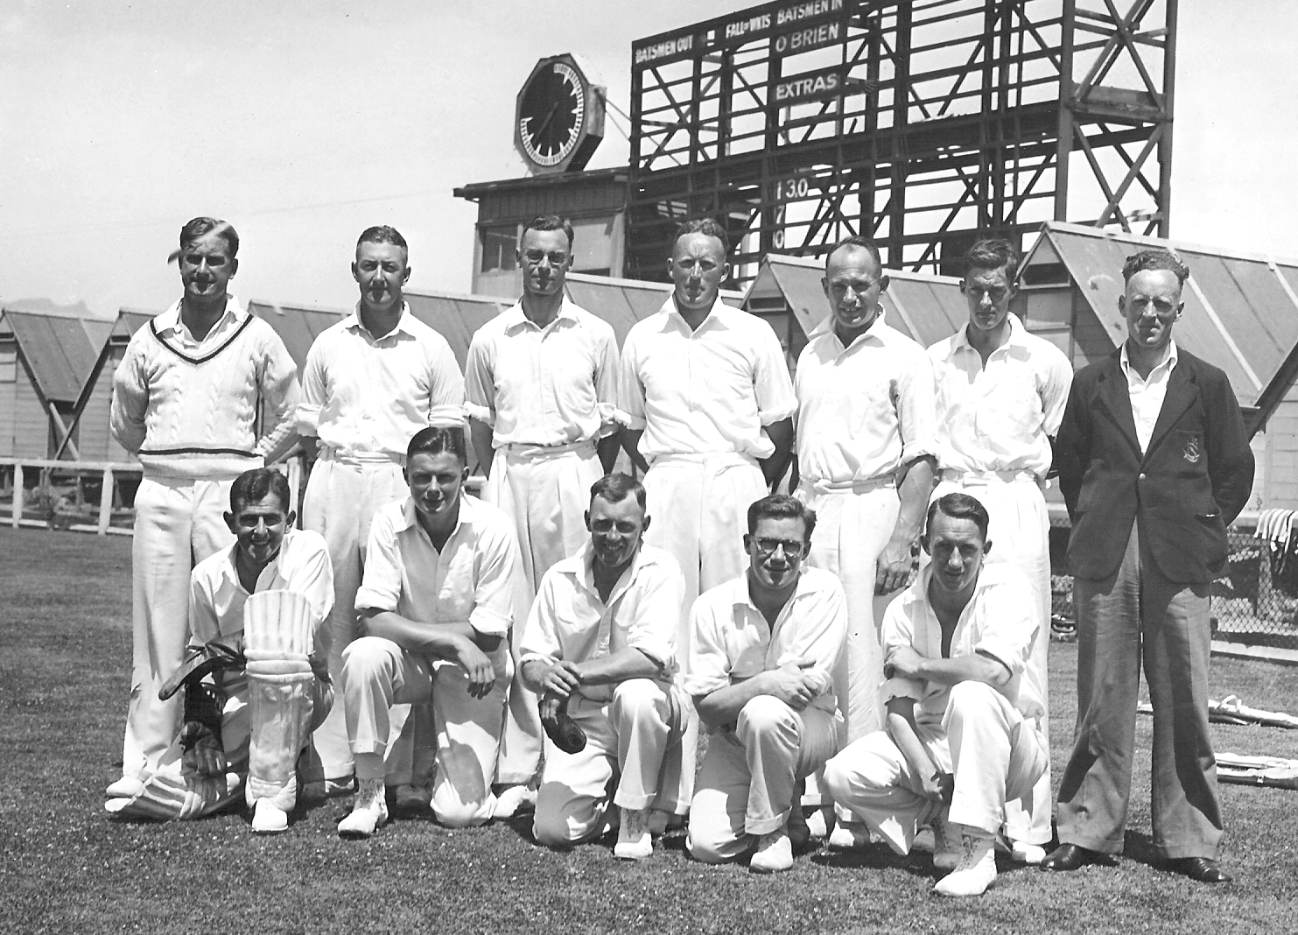

**Canterbury v Combined Services 31 January 1943 Lancaster Park**

**Back row:**  L Lohrey, FW O’Brien, WA Hadlee (captain), LA Butterfield, AW Roberts, IA Baxter, RCSA Shand

**Front row:** Sandston, I Proctor, DN Stokes, KFM Uttley, J Smith